RESOURCES FOR IMMIGRANTS

Using public food programs does NOT affect your immigration status Your personal information is NOT shared with immigration enforcement

Resources available to all who qualify
—regardless of immigration status
Pandemic EBT Women, Infants and

SNAP helps immigrant families save money
Receive up to $200 on an EBT card every month for food
Qualified immigrants and U.S. citizens are eligible

WIC
Children program School meals
Free meals for seniors and people with disabilities
Free food distributions
Undocumented immigrants, DACA recipients, and TPS holders can’t enroll in SNAP, but can enroll eligible family members

Undocumented parents can safely enroll citizen children and qualified household members
SNAP: Supplemental Nutrition Assistance Program also known as 'Food Stamps'

SNAP and all other public food programs are NOT a public charge
Find out if public charge applies to you: www.keepyourbenefits.org

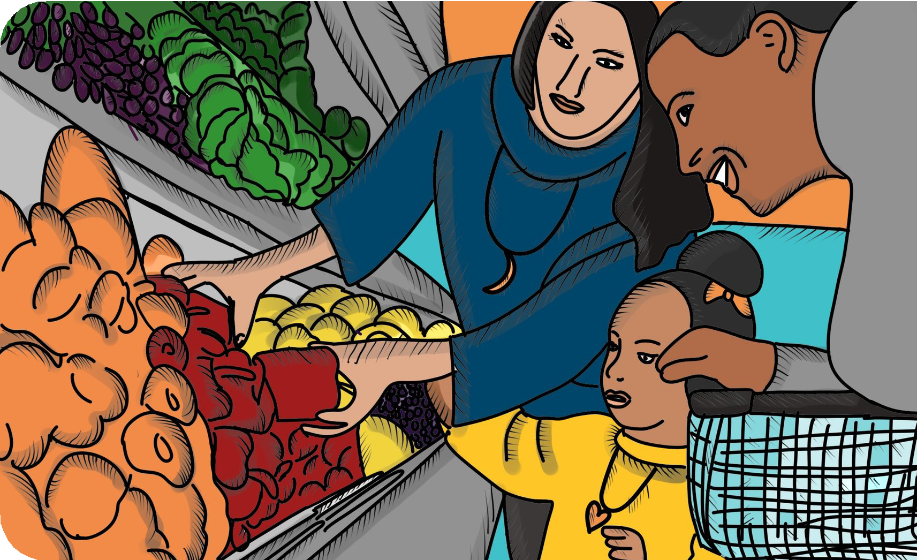LOCAL RESOURCES:

ADD REFERRAL INFORMATION FOR SCHOOL NUTRITION SERVICES, FOOD DISTRIBUTIONS AND SNAP APPLICATION ASSISTANCE.

SNAP provides EXTRA grocery money during COVID-19!
You may qualify if your family’s income is below the limit (low—no income)

Call to learn more:
[add contact info]

